Plenary speakers
PAUL LEWIS
Title: “Poe: Culture, Mystery, and Genre”
Abstract:

Then — in my childhood — in the dawn
Of a most stormy life — was drawn
From ev’ry depth of good and ill
The mystery which binds me still …
Poe, “Alone,” Unpublished ms., 1829

Poe’s hostility to didacticism, insistence on literary effects, and career-defining obsession with mystery have made him an elusive subject for historicists eager to recover what he believed about the turbulent issues that rocked antebellum America. On the one hand, Poe was a pen-and-ink scribbler who worked, feverously at times, within what he called “the magazine prison house”: absorbing massive quantities of texts as they were published and responding to current issues and events. An extremely partial list of these could include transcendentalism, populism, abolitionism, Native American removal, Western expansion, slave uprisings, romantic love, mourning, and mesmerism. On the other hand, a less reactive, more primal intention animates Poe’s writing. Regardless of the apparent subject and across the wide range of genres he engaged, one senses Poe’s (perhaps unconscious) effort to prove (perhaps mostly to himself) that he understood the mysteries that bound him as a child. In cypher-solving and hoaxing, gothic and detective fiction, but also and less obviously in book reviews, literary theory, and scientific speculation, Poe’s unstated subject and implicit theme was his own mastery and cleverness. Like the detective he created to embody this impulse, Poe implied that vexing subjects and mindnumbing mysteries were, for him, all too “plain” and “self-evident.” Poe was, it turns out, far more interested in making this point than in scoring points in then-current debates.
Bionote:
Paul Lewis is a Professor of the English Department at Boston College. His Academic specializations are: Literary Boston; American Humor Since 1980; American Literature: 1790-1860; Gothic Fiction.
Lewis is the president of the Poe Studies Association, the curator of three exhibitions on literary Boston, and the neologist who coined such words as "Frankenfood" and "lackspertise." He served as chairman of the Edgar Allan Poe Foundation of Boston from its inception in 2010 through the installation of the Rocknak statue in 2014 and as a founding member of the editorial board of HUMOR: International Journal of Humor Research.

JEFFREY A. SAVOYE
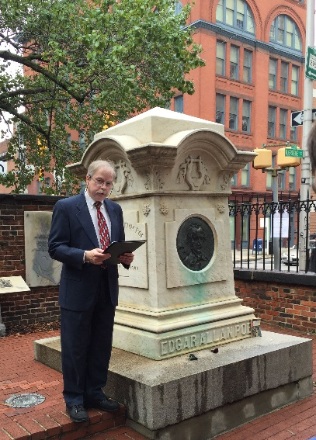Title: “The Works of the Late Edgar Allan Poe: Poe's Legacy and Griswold's Authority”
Abstract:
The single most significant of the early anthologies of Poe's writings is the four volume edition originally printed in 1850 and 1856 by J. S. Redfield. Because this set was prepared under the editorial attention of Rufus Wilmot Griswold, it is usually referred to as the Griswold edition. In many ways, it is the foundation stone upon which all subsequent editions have had to rely, but its reputation has also been marred by controversy and questions about its authority. In many cases, these questions have been raised unnecessarily, but in any case, claims for and against the set should be thoroughly evaluated. For the present study, I will examine the Griswold edition primarily on four kinds of authority: Aesthetic, Legal, Moral and Textual.
Bionote:
Jeffrey A. Savoye is an independent scholar, long and closely associated with the Edgar Allan Poe Society of Baltimore. He is also an honorary member of the Poe Studies Association and the Edgar Allan Poe Spanish Association. As the coeditor of The Collected Letters of Edgar Allan Poe (2008), the standard edition of Poe's correspondence, and the author of dozens of articles, published chiefly in The Edgar Allan Poe Review and in Poe Studies, he has deeply explored various aspects of Poe's life and writings. He is also the driving force behind the well-regarded web site of the Poe Society.

BARBARA CANTALUPO

Title: “Poe's Visual Legacy”
Abstract:
More than seven hundred artists have reacted to Poe’s work either as illustrators or simply as part of their own oeuvre. This prodigious response has much to do with the “graphicality” of Poe's writing. Poe coined this word in his entry on Margaret Fuller for the Literati of New York in which he wondered “(why is there not such a word?)" continuing with his definition of graphicality as "the force with which [descriptions] convey the true by the novel or unexpected, by the introduction of touches which other artists would be sure to omit as irrelevant to the subject.” Throughout Poe's fiction and poetry, the visual effect of the unexpected persists and has sparked the imaginations of many a visual artist. This talk will consider images by Frederick R. Pickersgill (1820-1900), James Ensor (1860-1949), Alfred Kubin (1877-1959), E. McKnight Kauffer (1890-1954), and Fritz Eichenberg (1901-1990), who either illustrated Poe's work or created their own art works related to Poe's themes.
Bionote:
Barbara Cantalupo is Professor of English at the Pennsylvania State University, founding and current editor of The Edgar Allan Poe Review, and editor of Lehigh University Press’ “Perspectives on Poe” series. Her monograph, Poe and the Visual Arts, won the Patrick Quinn Award for best monograph on Poe for 2014; heredited books include Poe's Pervasive Influence, Emma Wolf's Short Stories in the Smart Set, and Emma Wolf's Other Things Being Equal as well as a co-edited book with Richard Kopley, Prospects for the Study of American Literature, Vol. II. She and Richard Kopley are currently editing a collection of selected essays from the 2015 Poe Studies Association's Fourth International Edgar Allan Poe Conference, and she and Lori Harrison-Kahan are working together to re-issue a scholarly edition of Emma Wolf's 1900 novel, Heirs of Yesterday.

EMRON ESPLIN
Title: “Poe and His Global Advocates: The Influence of the Stars”
Abstract:
In this address, I explore Edgar Allan Poe’s extraordinary relationships with various literary traditions across the globe; I posit that Poe is the most influential U.S. writer on the global literary scene; and I argue that Poe’s current global reputation relies at least as much on the radiance of the work of Poe’s literary advocates—many of whom are literary stars in their own right—as it does on the brilliance of Poe’s original works. I briefly examine Poe’s most famous French advocates (Baudelaire, Mallarmé, Valéry), gloss the work of his advocates throughout Europe, Asia, and the Americas, and offer a concise case study of Poe’s influence on and advocacy from three twentieth century writers from the Río de la Plata region of South America (Quiroga, Borges, and Cortázar). I conclude by reading the relationships between Poe and his advocates through the ancient definition of astral or stellar influence.
Bionote:
Emron Esplin teaches courses in U.S. literature and inter-American literary studies at the English Department at Brigham Young University. He has published comparative articles on various literary and popular figures including Katherine Anne Porter, Nellie Campobello, Pancho Villa, William Faulkner, Edgar Allan Poe, Jorge Luis Borges, and Julio Cortázar. He co-edited Translated Poe (Lehigh UP 2014), a book of essays on Poe translations from nineteen different national/literary traditions, with Margarida Vale de Gato. His monograph, Borges's Poe: Influence and the Reinvention of Edgar Allan Poe in Spanish America was published in 2016.

